TANYA MISHRA

1BM18CS117

**Write a Shell Script to find Fibonacci Series Upto N using While loop Construct**

echo "Enter a number"

read n

x=0

y=1

i=2

echo "The Fibonacci series is : "

echo $x

echo $y

while [ $i -lt $n ]

do

i=`expr $i + 1 `

sum=`expr $x + $y `

echo "$sum"

x=$y

y=$sum

done

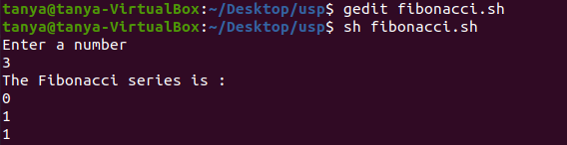

**Write a Shell Script to convert the Temperatures FAHERENHEIT to celsius**

#! /bin/bash

echo " Converting between the different temperature scales "

echo "1. Convert Celsius temperature into Fahrenheit"

echo "2. Convert Fahrenheit temperature into Celsius"

read ch

if [ $choice -eq 1 ]

then

echo -n "Enter temperature (C) : "

read tc

tf=$(echo "scale=2;((9/5) * $tc) + 32" |bc)

echo "$tc Celcius = $tf Fahrenheit"

elif [ $choice -eq 2 ]

then

echo -n "Enter temperature (F) : "

read tf

tc=$(echo "scale=2;(5/9)*($tf-32)"|bc)

echo "$tf Fahrenheit = $tc Celcius"

else

echo "Please select 1 or 2 only"

exit 1

fi

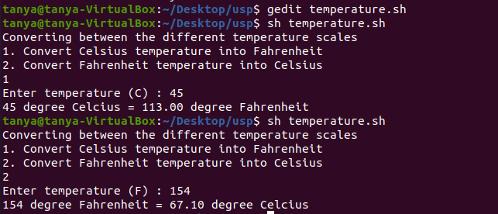

**Arithmetic Operations on a set of two numbers using case expression**

|  |
| --- |
| #!/bin/bash |
|  | echo "Enter Two numbers : " |
|  | read a |
|  | read b |
|  |  |
|  | # Input type of operation |
|  | echo "Enter Choice :" |
|  | echo "1. Addition" |
|  | echo "2. Subtraction" |
|  | echo "3. Multiplication" |
|  | echo "4. Division" |
|  | read ch |
|  |  |
|  | case $ch in |
|  | 1)res=`echo $a + $b | bc` |
|  | ;; |
|  | 2)res=`echo $a - $b | bc` |
|  | ;; |
|  | 3)res=`echo $a \* $b | bc` |
|  | ;; |
|  | 4)res=`echo "scale=2; $a / $b" | bc` |
|  | ;; |
|  | esac |
|  | echo "Result : $res" |

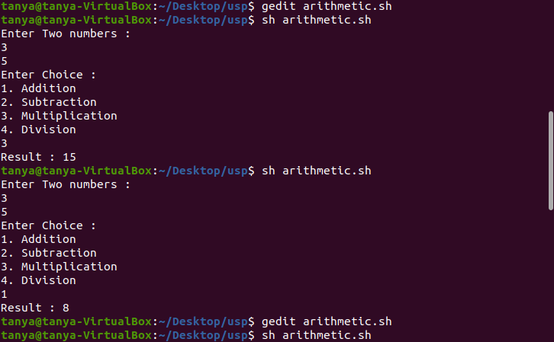

**Check whether the entered character is Vowel or consonant.**

echo "Enter any character: "read ch

case $ch in

"a") echo "It is a vowel.";;

"e") echo "It is a vowel.";;

"i") echo "It is a vowel.";;

"o") echo "It is a vowel.";;

"u") echo "It is a vowel.";;

*) echo "It is not a vowel."

Esac

